Mathematics

🌟 Definition
# Source: AI Source: Provided by: [Data Path: Persons Table -> ID Column: 1, Name_En Column: Motasem Essam] -> From: [ChatGPT] on [5/29/2026]
Mathematics is the branch of knowledge that studies numbers, quantities, shapes, patterns, structures, and logical relationships. It uses symbols, formulas, and reasoning to understand and explain the world.
Mathematics helps people:
- Solve problems
- Measure and calculate
- Analyze patterns
- Make predictions
- Develop technology and science
It is often called the language of science because it is used in fields such as physics, engineering, economics, computer science, and life science.

Etymology
# Source: Wiki source: Provided by: [Data Path: Persons Table -> ID Column: 1, Name_En Column: Motasem Essam] -> From: [Data Path: Sources Table -> ID Column: 306, Content Title Column: Wiki Source - Mathematics] -> at: [Document, page: 1, History -> Etymology] on [5/29/2025]
The word mathematics comes from the Ancient Greek word máthēma (μάθημα), meaning 'something learned, knowledge, mathematics', and the derived expression mathēmatikḗ tékhnē (μαθηματικὴ τέχνη), meaning 'mathematical science'. It entered the English language during the Late Middle English period through French and Latin.[64]

Traditionally, one of the two main schools of thought in Pythagoreanism was known as the mathēmatikoi (μαθηματικοί)—which at the time meant "learners" rather than "mathematicians" in the modern sense. The Pythagoreans were likely the first to constrain the use of the word to just the study of arithmetic and geometry. By the time of Aristotle (384–322 BC) this meaning was fully established.[65]

In Latin and English, until around 1700, the term mathematics more commonly meant "astrology" (or sometimes "astronomy") rather than "mathematics"; the meaning gradually changed to its present one from about 1500 to 1800. This change has resulted in several mistranslations: For example, Saint Augustine's warning that Christians should beware of mathematici, meaning "astrologers", is sometimes mistranslated as a condemnation of mathematicians.[66]

The apparent plural form in English goes back to the Latin neuter plural mathematica (Cicero), based on the Greek plural ta mathēmatiká (τὰ μαθηματικά) and means roughly "all things mathematical", although it is plausible that English borrowed only the adjective mathematic(al) and formed the noun mathematics anew, after the pattern of physics and metaphysics, inherited from Greek.[67] In English, the noun mathematics takes a singular verb. It is often shortened to maths[68] or, in North America, math.[69

🔢 Main Branches of Mathematics

1. Foundations and Philosophy of Mathematics

🌟 Definition
# Source: AI Source: Provided by: [Data Path: Persons Table -> ID Column: 1, Name_En Column: Motasem Essam] -> From: [ChatGPT] on [5/29/2026]
Foundations and Philosophy of Mathematics studies the nature, meaning, principles, and certainty of mathematics. It examines how mathematics is built and what makes mathematical statements true.

📚 Main Branches
# Source: AI Source: Provided by: [Data Path: Persons Table -> ID Column: 1, Name_En Column: Motasem Essam] -> From: [ChatGPT] on [5/29/2026]
- Philosophy of Mathematics
- Foundations of Mathematics
- Axiomatic Systems
- Formal Systems
- Mathematical Epistemology

🎯 Purpose
# Source: AI Source: Provided by: [Data Path: Persons Table -> ID Column: 1, Name_En Column: Motasem Essam] -> From: [ChatGPT] on [5/29/2026]
- To understand mathematical truth
- To study the foundations of mathematical systems
- To analyze certainty and consistency in mathematics
- To examine how mathematical knowledge is formed

✏️ Example
# Source: AI Source: Provided by: [Data Path: Persons Table -> ID Column: 1, Name_En Column: Motasem Essam] -> From: [ChatGPT] on [5/29/2026]
Euclidean geometry begins with axioms accepted without proof.
Example axiom:
$$a=a$$

❓ Example Question
# Source: AI Source: Provided by: [Data Path: Persons Table -> ID Column: 1, Name_En Column: Motasem Essam] -> From: [ChatGPT] on [5/29/2026]
Can all mathematical truths be proven from basic axioms?

2. Mathematical Logic

🌟 Definition
# Source: AI Source: Provided by: [Data Path: Persons Table -> ID Column: 1, Name_En Column: Motasem Essam] -> From: [ChatGPT] on [5/29/2026]
Mathematical Logic is the branch of mathematics that studies logical reasoning, proofs, and mathematical thinking. It forms the foundation of all mathematics.

📚 Main Branches
# Source: AI Source: Provided by: [Data Path: Persons Table -> ID Column: 1, Name_En Column: Motasem Essam] -> From: [ChatGPT] on [5/29/2026]
- Propositional Logic
- Predicate Logic
- Set Theory
- Proof Theory
- Model Theory
- Recursion Theory
- Computability Theory

🎯 Purpose
# Source: AI Source: Provided by: [Data Path: Persons Table -> ID Column: 1, Name_En Column: Motasem Essam] -> From: [ChatGPT] on [5/29/2026]
- To develop correct mathematical reasoning
- To verify mathematical proofs
- To establish foundations of mathematics
- To study computability and logical systems

✏️ Example
# Source: AI Source: Provided by: [Data Path: Persons Table -> ID Column: 1, Name_En Column: Motasem Essam] -> From: [ChatGPT] on [5/29/2026]
If all humans are mortal and Socrates is human, then Socrates is mortal.

3. Pure Mathematics

🌟 Definition:
# Source: AI Source: Provided by: [Data Path: Persons Table -> ID Column: 1, Name_En Column: Motasem Essam] -> From: [ChatGPT] on [5/29/2026]
Pure mathematics studies mathematical concepts, structures, and theories without focusing mainly on practical applications. It is concerned with abstract ideas and logical reasoning.

📘 Main Branches of Pure Mathematics

1. Quantity

🌟 Definition
# Source: AI Source: Provided by: [Data Path: Persons Table -> ID Column: 1, Name_En Column: Motasem Essam] -> From: [ChatGPT] on [5/29/2026]
Quantity is the branch of mathematics that studies numbers, amounts, and measurement.

📚 Main Branches
# Source: AI Source: Provided by: [Data Path: Persons Table -> ID Column: 1, Name_En Column: Motasem Essam] -> From: [ChatGPT] on [5/29/2026]
- Arithmetic
- Number Theory

🎯 Purpose
# Source: AI Source: Provided by: [Data Path: Persons Table -> ID Column: 1, Name_En Column: Motasem Essam] -> From: [ChatGPT] on [5/29/2026]
- To calculate and measure quantities
- To understand number properties
- To solve numerical problems

✏️ Example
# Source: AI Source: Provided by: [Data Path: Persons Table -> ID Column: 1, Name_En Column: Motasem Essam] -> From: [ChatGPT] on [5/29/2026]
$$15+10=25$$

2. Structure

🌟 Definition
# Source: AI Source: Provided by: [Data Path: Persons Table -> ID Column: 1, Name_En Column: Motasem Essam] -> From: [ChatGPT] on [5/29/2026]
Structure is the branch of mathematics that studies patterns, relationships, and algebraic systems.

📚 Main Branches
# Source: AI Source: Provided by: [Data Path: Persons Table -> ID Column: 1, Name_En Column: Motasem Essam] -> From: [ChatGPT] on [5/29/2026]
- Algebra
- Linear Algebra
- Abstract Algebra
- Group Theory
- Ring Theory

🎯 Purpose
# Source: AI Source: Provided by: [Data Path: Persons Table -> ID Column: 1, Name_En Column: Motasem Essam] -> From: [ChatGPT] on [5/29/2026]
- To study mathematical relationships
- To analyze patterns and systems
- To build abstract mathematical models

✏️ Example
# Source: AI Source: Provided by: [Data Path: Persons Table -> ID Column: 1, Name_En Column: Motasem Essam] -> From: [ChatGPT] on [5/29/2026]
$$a+b=b+a$$

3. Space

🌟 Definition
# Source: AI Source: Provided by: [Data Path: Persons Table -> ID Column: 1, Name_En Column: Motasem Essam] -> From: [ChatGPT] on [5/29/2026]
Space is the branch of mathematics that studies shapes, size, dimensions, and positions of objects.

📚 Main Branches
# Source: AI Source: Provided by: [Data Path: Persons Table -> ID Column: 1, Name_En Column: Motasem Essam] -> From: [ChatGPT] on [5/29/2026]
- Euclidean Geometry
- Analytic Geometry
- Trigonometry
- Topology
- Solid Geometry

🎯 Purpose
# Source: AI Source: Provided by: [Data Path: Persons Table -> ID Column: 1, Name_En Column: Motasem Essam] -> From: [ChatGPT] on [5/29/2026]
- To study geometric shapes and structures
- To measure area, volume, and angles
- To understand spatial relationships

✏️ Example
# Source: AI Source: Provided by: [Data Path: Persons Table -> ID Column: 1, Name_En Column: Motasem Essam] -> From: [ChatGPT] on [5/29/2026]
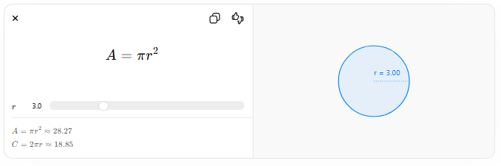
$$A=πr^{2}$$
$$r$$
$$A=πr^{2}≈28.27$$
$$C=2πr≈18.85$$
r = 3.00

4. Change

🌟 Definition
# Source: AI Source: Provided by: [Data Path: Persons Table -> ID Column: 1, Name_En Column: Motasem Essam] -> From: [ChatGPT] on [5/29/2026]
Change is the branch of mathematics that studies motion, variation, and changing quantities.

📚 Main Branches
# Source: AI Source: Provided by: [Data Path: Persons Table -> ID Column: 1, Name_En Column: Motasem Essam] -> From: [ChatGPT] on [5/29/2026]
- Calculus
- Differential Equations
- Mathematical Analysis
- Dynamical Systems

🎯 Purpose
# Source: AI Source: Provided by: [Data Path: Persons Table -> ID Column: 1, Name_En Column: Motasem Essam] -> From: [ChatGPT] on [5/29/2026]
- To study rates of change and motion
- To model real-world processes
- To predict changing behavior over time

✏️ Example
# Source: AI Source: Provided by: [Data Path: Persons Table -> ID Column: 1, Name_En Column: Motasem Essam] -> From: [ChatGPT] on [5/29/2026]
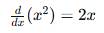
$$\frac{d}{dx}(x^{2})=2x$$

🧭 Final Summary
# Source: AI Source: Provided by: [Data Path: Persons Table -> ID Column: 1, Name_En Column: Motasem Essam] -> From: [ChatGPT] on [5/29/2026]
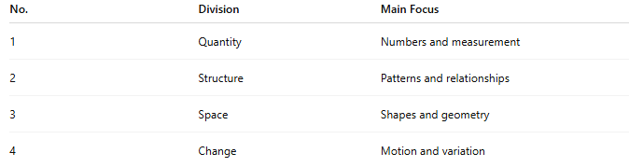
No. | Division | Main Focus
1 | Quantity | Numbers and measurement
2 | Structure | Patterns and relationships
3 | Space | Shapes and geometry
4 | Change | Motion and variation

Purpose
# Source: AI Source: Provided by: [Data Path: Persons Table -> ID Column: 1, Name_En Column: Motasem Essam] -> From: [ChatGPT] on [5/29/2026]
- Develop mathematical theories
- Understand patterns and relationships
- Advance logical thinking

Example Question
# Source: AI Source: Provided by: [Data Path: Persons Table -> ID Column: 1, Name_En Column: Motasem Essam] -> From: [ChatGPT] on [5/29/2026]
What properties do prime numbers have?

4. Applied Mathematics

🌟 Definition:
# Source: AI Source: Provided by: [Data Path: Persons Table -> ID Column: 1, Name_En Column: Motasem Essam] -> From: [ChatGPT] on [5/29/2026]
Applied mathematics uses mathematical methods to solve real-world problems in science, engineering, business, technology, and everyday life.

Main Areas
# Source: AI Source: Provided by: [Data Path: Persons Table -> ID Column: 1, Name_En Column: Motasem Essam] -> From: [ChatGPT] on [5/29/2026]
- Statistics
- Probability
- Operations Research
- Engineering Mathematics
- Computational Mathematics
- Mathematical Modeling
Example formula:
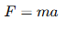
$$F=ma$$

Purpose
# Source: AI Source: Provided by: [Data Path: Persons Table -> ID Column: 1, Name_En Column: Motasem Essam] -> From: [ChatGPT] on [5/29/2026]
- Solve practical problems
- Predict outcomes
- Improve technology and scientific research

Example Question
# Source: AI Source: Provided by: [Data Path: Persons Table -> ID Column: 1, Name_En Column: Motasem Essam] -> From: [ChatGPT] on [5/29/2026]
How can mathematics predict weather changes?

5. Discrete Mathematics

🌟 Definition
# Source: AI Source: Provided by: [Data Path: Persons Table -> ID Column: 1, Name_En Column: Motasem Essam] -> From: [ChatGPT] on [5/29/2026]
Discrete Mathematics is the branch of mathematics that studies countable, separate, and distinct mathematical structures rather than continuous quantities. It focuses on finite or discrete systems used widely in computer science and digital technology.

📚 Main Branches
# Source: AI Source: Provided by: [Data Path: Persons Table -> ID Column: 1, Name_En Column: Motasem Essam] -> From: [ChatGPT] on [5/29/2026]
- Graph Theory
- Combinatorics
- Boolean Algebra
- Coding Theory
- Cryptography
- Number Theory
- Discrete Probability
- Algorithms Theory

🎯 Purpose
# Source: AI Source: Provided by: [Data Path: Persons Table -> ID Column: 1, Name_En Column: Motasem Essam] -> From: [ChatGPT] on [5/29/2026]
- To study finite and countable structures
- To support computer science and programming
- To develop algorithms and data structures
- To solve network and optimization problems
- To improve cryptography and digital communication

✏️ Example
# Source: AI Source: Provided by: [Data Path: Persons Table -> ID Column: 1, Name_En Column: Motasem Essam] -> From: [ChatGPT] on [5/29/2026]
A graph with connected nodes:
$$V=\{A,B,C,D\}, E=\{(A,B),(B,C),(C,D)\}$$

❓ Example Question
# Source: AI Source: Provided by: [Data Path: Persons Table -> ID Column: 1, Name_En Column: Motasem Essam] -> From: [ChatGPT] on [5/29/2026]
How can a computer find the shortest path between two locations?

🔍 Difference Between Them
# Source: AI Source: Provided by: [Data Path: Persons Table -> ID Column: 1, Name_En Column: Motasem Essam] -> From: [ChatGPT] on [5/29/2026]
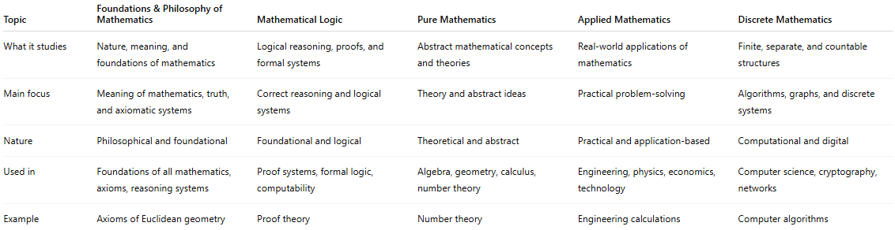
Topic | Foundations & Philosophy of Mathematics | Mathematical Logic | Pure Mathematics | Applied Mathematics | Discrete Mathematics
What it studies | Nature, meaning, and foundations of mathematics | Logical reasoning, proofs, and formal systems | Abstract mathematical concepts and theories | Real-world applications of mathematics | Finite, separate, and countable structures
Main focus | Meaning of mathematics, truth, and axiomatic systems | Correct reasoning and logical systems | Theory and abstract ideas | Practical problem-solving | Algorithms, graphs, and discrete systems
Nature | Philosophical and foundational | Foundational and logical | Theoretical and abstract | Practical and application-based | Computational and digital
Used in | Foundations of all mathematics, axioms, reasoning systems | Proof systems, formal logic, computability | Algebra, geometry, calculus, number theory | Engineering, physics, economics, technology | Computer science, cryptography, networks
Example | Axioms of Euclidean geometry | Proof theory | Number theory | Engineering calculations | Computer algorithms

🧭 Summary
# Source: AI Source: Provided by: [Data Path: Persons Table -> ID Column: 1, Name_En Column: Motasem Essam] -> From: [ChatGPT] on [5/29/2026]
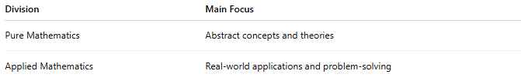
Division | Main Focus
Pure Mathematics | Abstract concepts and theories
Applied Mathematics | Real-world applications and problem-solving

🧠 Importance of Mathematics
# Source: AI Source: Provided by: [Data Path: Persons Table -> ID Column: 1, Name_En Column: Motasem Essam] -> From: [ChatGPT] on [5/29/2026]
Mathematics is important because it:
- Develops logical thinking
- Helps solve real-world problems
- Supports science and technology
- Improves financial and business decisions
- Powers computers, engineering, and AI

🌍 Mathematics in Daily Life
# Source: AI Source: Provided by: [Data Path: Persons Table -> ID Column: 1, Name_En Column: Motasem Essam] -> From: [ChatGPT] on [5/29/2026]
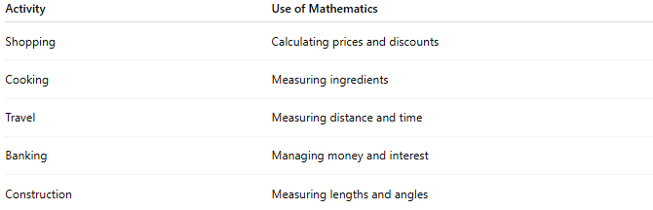
Activity | Use of Mathematics
Shopping | Calculating prices and discounts
Cooking | Measuring ingredients
Travel | Measuring distance and time
Banking | Managing money and interest
Construction | Measuring lengths and angles

👨‍🏫 Famous Mathematicians
# Source: AI Source: Provided by: [Data Path: Persons Table -> ID Column: 1, Name_En Column: Motasem Essam] -> From: [ChatGPT] on [5/29/2026]
- Pythagoras — Pythagorean theorem
- Isaac Newton — Calculus
- Euclid — Geometry foundations
- Carl Friedrich Gauss — Number theory and statistics
- Ada Lovelace — Early computing concepts

🧭 Summary
# Source: AI Source: Provided by: [Data Path: Persons Table -> ID Column: 1, Name_En Column: Motasem Essam] -> From: [ChatGPT] on [5/29/2026]
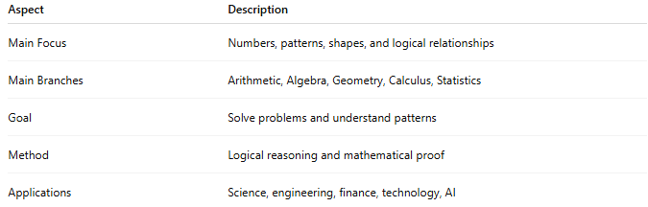
Aspect | Description
Main Focus | Numbers, patterns, shapes, and logical relationships
Main Branches | Arithmetic, Algebra, Geometry, Calculus, Statistics
Goal | Solve problems and understand patterns
Method | Logical reasoning and mathematical proof
Applications | Science, engineering, finance, technology, AI

